L5

Sokolova V

#Зчитати дані у формі часового ряду (або взяти готовий датасет в цьому форматі)  
meat<- read.csv(file = "C:\\Users\\User\\Desktop\\3курс\\mmoi\\5\\meat_prices_20180103_20211027.csv", header = TRUE)  
beef <- subset(meat, (meat_type == "Beef, kg" ) , select = c(price))  
beef.ts <- ts(beef, frequency = 80, start = c(2018, 1))

#Зобразити отриманий часовий ряд (з підписами)  
plot.ts(beef.ts,xlab = "Ціна" , ylab = "Час",main = "Зміна цін на яловичину")

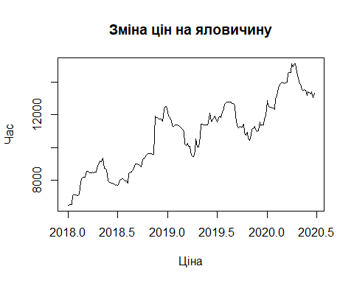

#Провести згладжування ряду методом рухомого середнього з різним кроком  
library(TTR)

## Warning: package 'TTR' was built under R version 4.1.2

plot.ts(SMA(beef.ts, n=5))

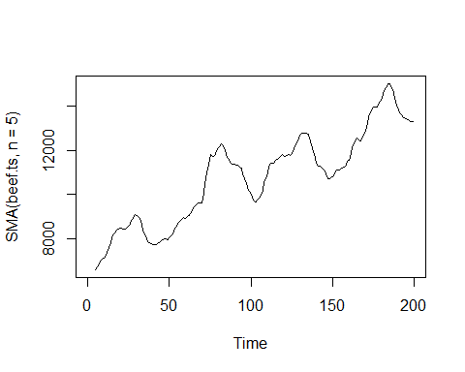

SMA(beef.ts,order=3, silent=F)

## [1] NA NA NA NA NA NA NA NA  
## [9] NA 6867.00 6975.00 7135.00 7300.50 7468.00 7580.50 7716.50  
## [17] 7857.00 7996.50 8132.50 8260.50 8354.50 8394.50 8426.50 8455.50  
## [25] 8527.50 8578.50 8642.00 8705.00 8795.50 8825.00 8847.00 8864.50  
## [33] 8812.50 8754.50 8650.50 8530.50 8395.50 8262.50 8098.50 7996.50  
## [41] 7894.50 7810.50 7810.50 7823.00 7843.00 7861.50 7877.00 7893.50  
## [49] 7907.00 7978.00 8053.50 8124.50 8184.50 8255.50 8345.70 8441.90  
## [57] 8544.80 8646.80 8754.40 8795.00 8878.40 8956.40 9037.70 9116.60  
## [65] 9182.60 9248.60 9313.40 9379.00 9447.80 9525.10 9788.40 10043.40  
## [73] 10289.10 10509.80 10718.30 10926.80 11124.00 11392.30 11678.10 11968.20  
## [81] 11997.50 12006.50 12004.00 11995.90 11959.61 11917.72 11895.46 11802.51  
## [89] 11694.26 11579.59 11484.34 11409.19 11340.37 11271.93 11155.29 11038.01  
## [97] 10926.32 10797.27 10668.22 10485.62 10309.09 10135.94 9997.06 9954.20  
## [105] 9936.13 9925.40 9963.15 10098.45 10235.25 10422.42 10613.60 10807.80  
## [113] 10971.50 11071.40 11280.30 11439.10 11535.50 11570.20 11618.20 11657.60  
## [121] 11673.00 11717.80 11770.70 11798.60 11805.50 11881.90 11984.30 12081.00  
## [129] 12167.20 12266.80 12390.40 12485.30 12564.80 12653.20 12692.20 12647.90  
## [137] 12518.80 12363.80 12212.30 12058.50 11906.10 11771.40 11594.90 11401.10  
## [145] 11239.20 11105.20 11013.20 10970.40 10954.00 10942.90 10944.00 10910.40  
## [153] 10913.40 10938.80 11002.80 11078.60 11172.80 11235.10 11298.20 11379.40  
## [161] 11538.10 11687.20 11839.00 11983.10 12066.10 12172.90 12268.30 12427.00  
## [169] 12573.20 12741.60 12841.50 12972.10 13123.40 13272.50 13424.00 13576.10  
## [177] 13742.60 13900.60 14040.10 14134.10 14262.00 14367.70 14480.10 14597.30  
## [185] 14670.20 14703.00 14694.00 14623.20 14516.60 14410.40 14253.80 14108.70  
## [193] 13917.40 13747.40 13618.10 13521.30 13471.80 13394.40 13372.90

plot.ts(SMA(beef.ts, n=30))

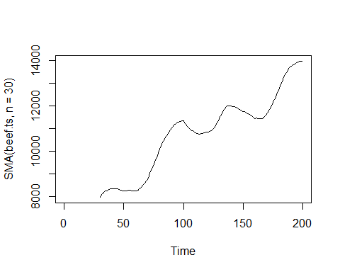

plot.ts(SMA(beef.ts, n=50))

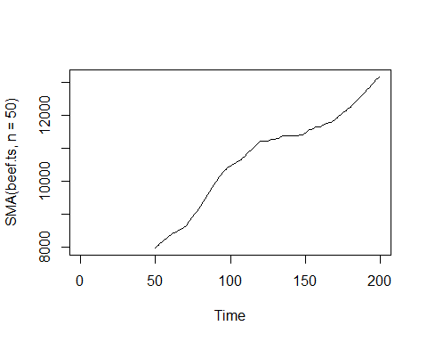

plot.ts(SMA(beef.ts, n=100))

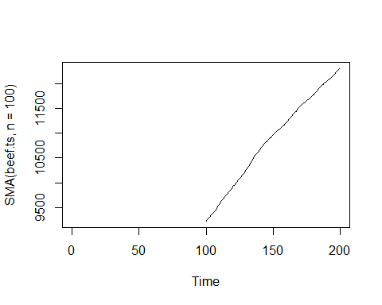

#Розбити вихідний часовий ряд на систематичну, періодичну та хаотичну складові  
dec<-decompose(beef.ts)  
plot(dec)

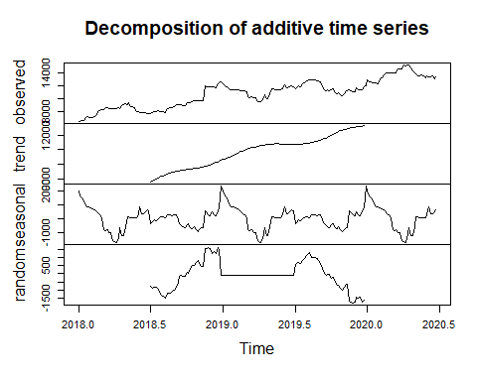

#Побудувати корелограму та частинну корелограму ЧР  
library(forecast)

## Warning: package 'forecast' was built under R version 4.1.2

## Registered S3 method overwritten by 'quantmod':  
## method from  
## as.zoo.data.frame zoo

ggtsdisplay(beef.ts)

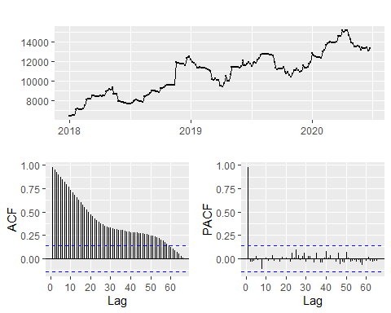

#За потреби трансформувати ЧР  
trbeef1<-diff(beef.ts,lag = 7)  
plot(trbeef1, main="first diff")

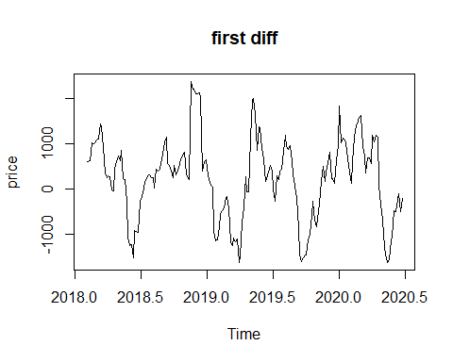

trbeef2<-diff(trbeef1)  
plot(trbeef2, main="second diff")

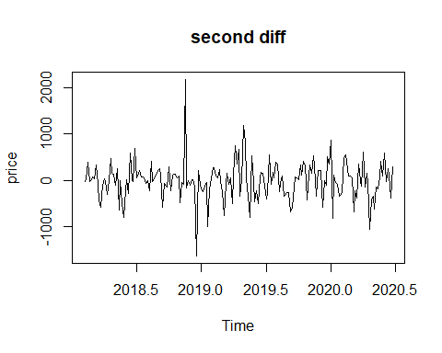

ggtsdisplay(trbeef2)

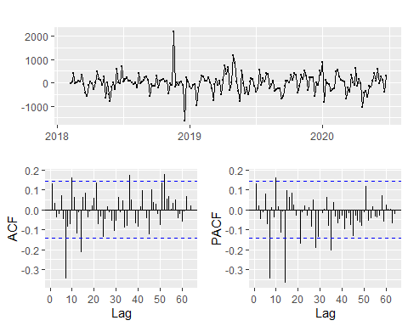

#Побудувати прогноз відповідним до моделі ЧР методом експоненційного згладжування та відповідним до ряду методом з групи ARIMA  
hlt <- HoltWinters(beef.ts, gamma = FALSE)  
p=predict(hlt, 100, prediction.interval = T)  
plot(hlt, p,ylab="beef price")

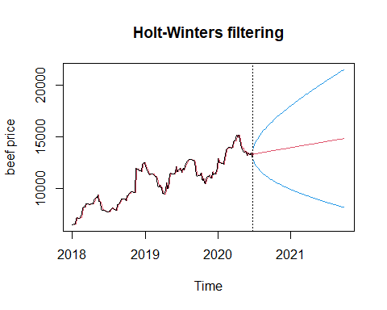

frcst <- forecast(trbeef2)  
plot(frcst)

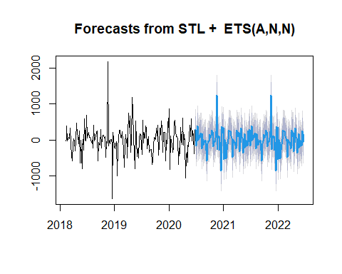

arima.beef = arima(trbeef2, order = c(1,1,1))  
checkresiduals(arima.beef$residuals)

## Warning in modeldf.default(object): Could not find appropriate degrees of  
## freedom for this model.

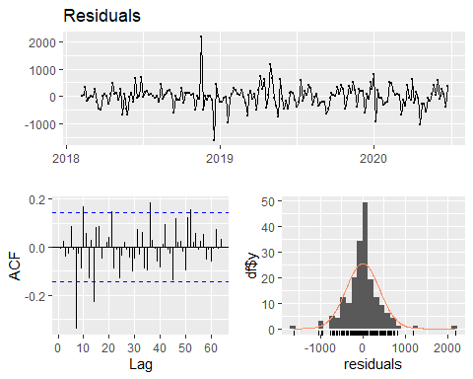

arima.beefauto = auto.arima(trbeef2, d=0, approximation=FALSE)  
checkresiduals(arima.beefauto$residuals)

## Warning in modeldf.default(object): Could not find appropriate degrees of  
## freedom for this model.

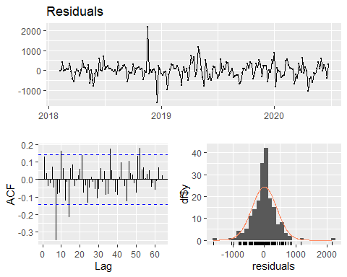

arima.beef1 = auto.arima(beef.ts, d=0, approximation=FALSE)  
plot(forecast(auto.arima(beef.ts, d=1)))

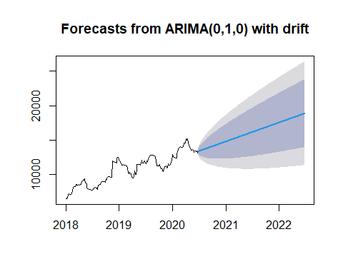

checkresiduals(arima.beef1$residuals)

## Warning in modeldf.default(object): Could not find appropriate degrees of  
## freedom for this model.

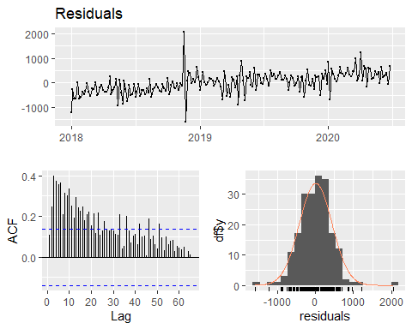

shapiro.test(arima.beef1$residuals)

##   
## Shapiro-Wilk normality test  
##   
## data: arima.beef1$residuals  
## W = 0.97061, p-value = 0.0003499

Box.test(arima.beef1$residuals)

##   
## Box-Pierce test  
##   
## data: arima.beef1$residuals  
## X-squared = 2.2418, df = 1, p-value = 0.1343

#Побудувати корелограми залишків та інші діаграми, що характеризують розподіл залишків моделі  
frcst$residuals

## Time Series:  
## Start = c(2018, 9)   
## End = c(2020, 39)   
## Frequency = 80   
## [1] -264.3106117 -193.6300898 144.0875881 -139.7165871 -32.5237394  
## [6] 97.1806280 482.2146766 292.3519534 -2.0646432 -377.4009728  
## [11] -404.6973533 129.1470672 -221.8477633 -233.0065416 -375.9934832  
## [16] -231.1054084 736.7028530 220.5982950 -228.6151795 -174.3415208  
## [21] 177.0929803 -250.8752727 236.9976554 -639.3991090 -541.5368158  
## [26] -160.1549293 85.7408647 -94.8912781 316.2844789 46.7579572  
## [31] -165.0027266 387.0551290 212.6837599 195.6761793 -178.4744659  
## [36] 74.2680630 -61.7739281 -26.8860018 -237.5077180 -181.3612393  
## [41] 2.7194495 233.2154854 -65.8539800 177.5315892 197.1216126  
## [46] 231.0349853 247.1624360 380.1430873 -0.6247717 40.9950738  
## [51] -104.1122330 -105.9519386 130.3050502 -273.6546990 -19.5977942  
## [56] -145.9278534 -96.3897628 233.2215393 106.8598745 -401.3327250  
## [61] -103.3053960 -311.5426800 916.7235457 79.5525804 -106.9681924  
## [66] -165.0365064 -106.5206380 291.3510013 -53.7573043 -749.0601906  
## [71] -149.0880321 -151.2888097 -519.0317276 278.5515556 -118.3792991  
## [76] -7.9120294 -453.1295943 62.8761900 166.5578566 258.6207128  
## [81] 7.1524878 -138.6046372 -183.3595956 115.6175291 -43.8921369  
## [86] -211.3571824 -299.7113094 -94.0998031 244.7611945 -40.9512034  
## [91] 219.5946927 -269.8669869 -145.7903639 532.8534894 269.6631588  
## [96] 439.8961001 -49.1375480 83.0595139 836.3594013 765.5703370  
## [101] -15.1529891 32.0935161 -553.0235645 364.2397189 202.4957950  
## [106] -442.4756211 -158.3712243 -334.5273115 -206.9126149 232.0058724  
## [111] -2.7020460 -408.1392727 -232.6938990 -215.0821780 159.6725472  
## [116] -92.4659622 44.1799881 9.8965184 221.1220473 165.5793210  
## [121] -17.8976758 -247.7900801 51.8829565 -190.8214490 -209.7303769  
## [126] -242.9627221 -258.4086015 -391.1485047 -10.1399216 -51.5190673  
## [131] 93.8289154 95.9092728 -140.1070883 264.0932645 10.2769393  
## [136] 136.8476469 87.5500909 -241.8331859 -115.2435186 393.1770606  
## [141] 95.3776886 304.0266471 -923.8279451 -86.2453876 100.6867863  
## [146] 159.1667584 101.0625067 -296.3975569 49.1222832 744.8366628  
## [151] 145.2759565 146.9989399 514.2641114 -283.7972199 112.6560717  
## [156] 1.8021880 446.6331777 -69.7591432 -173.8273077 -266.2766232  
## [161] 217.2337213 298.4416995 7.3734594 -20.3223208 38.7022608  
## [166] 83.6560291 -209.1490174 -233.3529253 -291.8414340 381.3460858  
## [171] 137.3234046 113.6250065 335.4935996 -360.3016625 57.0693423  
## [176] -265.0682203 -723.2073651 -344.7210778 -680.2800128 -659.6747003  
## [181] -196.5193940 183.3407516 306.2468079 228.0051426 299.7689856  
## [186] 591.5089281 50.6902373 415.9648485 -127.0805058 -313.7761514  
## [191] 143.6430331

pacf(frcst$residuals, main = "PACF", na.action = na.pass)

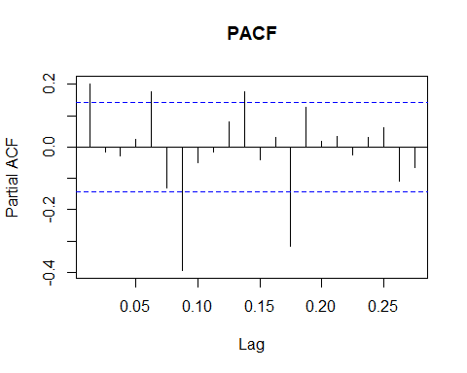

library(astsa)

##   
## Attaching package: 'astsa'

## The following object is masked from 'package:forecast':  
##   
## gas

sarima(beef.ts,1,1,1)

## initial value 5.717053   
## iter 2 value 5.717037  
## iter 3 value 5.713440  
## iter 4 value 5.713439  
## iter 5 value 5.713439  
## iter 6 value 5.713439  
## iter 7 value 5.713438  
## iter 8 value 5.713436  
## iter 9 value 5.713435  
## iter 10 value 5.713434  
## iter 11 value 5.713434  
## iter 12 value 5.713434  
## iter 13 value 5.713433  
## iter 14 value 5.713431  
## iter 15 value 5.713427  
## iter 16 value 5.713425  
## iter 17 value 5.713422  
## iter 18 value 5.713422  
## iter 19 value 5.713422  
## iter 20 value 5.713422  
## iter 21 value 5.713421  
## iter 22 value 5.713420  
## iter 23 value 5.713420  
## iter 24 value 5.713419  
## iter 25 value 5.713419  
## iter 26 value 5.713419  
## iter 27 value 5.713418  
## iter 28 value 5.713417  
## iter 29 value 5.713415  
## iter 30 value 5.713414  
## iter 31 value 5.713412  
## iter 32 value 5.713412  
## iter 33 value 5.713412  
## iter 33 value 5.713412  
## iter 33 value 5.713412  
## final value 5.713412   
## converged  
## initial value 5.710922   
## iter 2 value 5.710922  
## iter 3 value 5.710921  
## iter 4 value 5.710921  
## iter 5 value 5.710921  
## iter 6 value 5.710921  
## iter 7 value 5.710920  
## iter 8 value 5.710917  
## iter 9 value 5.710915  
## iter 10 value 5.710914  
## iter 11 value 5.710914  
## iter 11 value 5.710914  
## iter 11 value 5.710914  
## final value 5.710914   
## converged

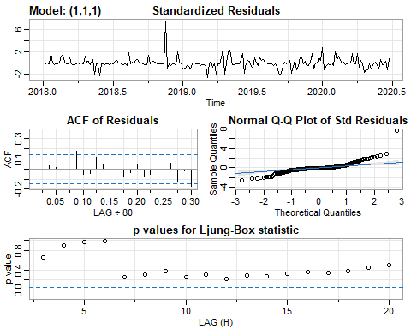

## $fit  
##   
## Call:  
## arima(x = xdata, order = c(p, d, q), seasonal = list(order = c(P, D, Q), period = S),   
## xreg = constant, transform.pars = trans, fixed = fixed, optim.control = list(trace = trc,   
## REPORT = 1, reltol = tol))  
##   
## Coefficients:  
## ar1 ma1 constant  
## 0.1497 -0.0655 34.7114  
## s.e. 1.7559 1.7728 23.5854  
##   
## sigma^2 estimated as 91290: log likelihood = -1411.71, aic = 2831.42  
##   
## $degrees_of_freedom  
## [1] 195  
##   
## $ttable  
## Estimate SE t.value p.value  
## ar1 0.1497 1.7559 0.0853 0.9321  
## ma1 -0.0655 1.7728 -0.0370 0.9705  
## constant 34.7114 23.5854 1.4717 0.1427  
##   
## $AIC  
## [1] 14.30011  
##   
## $AICc  
## [1] 14.30073  
##   
## $BIC  
## [1] 14.36654